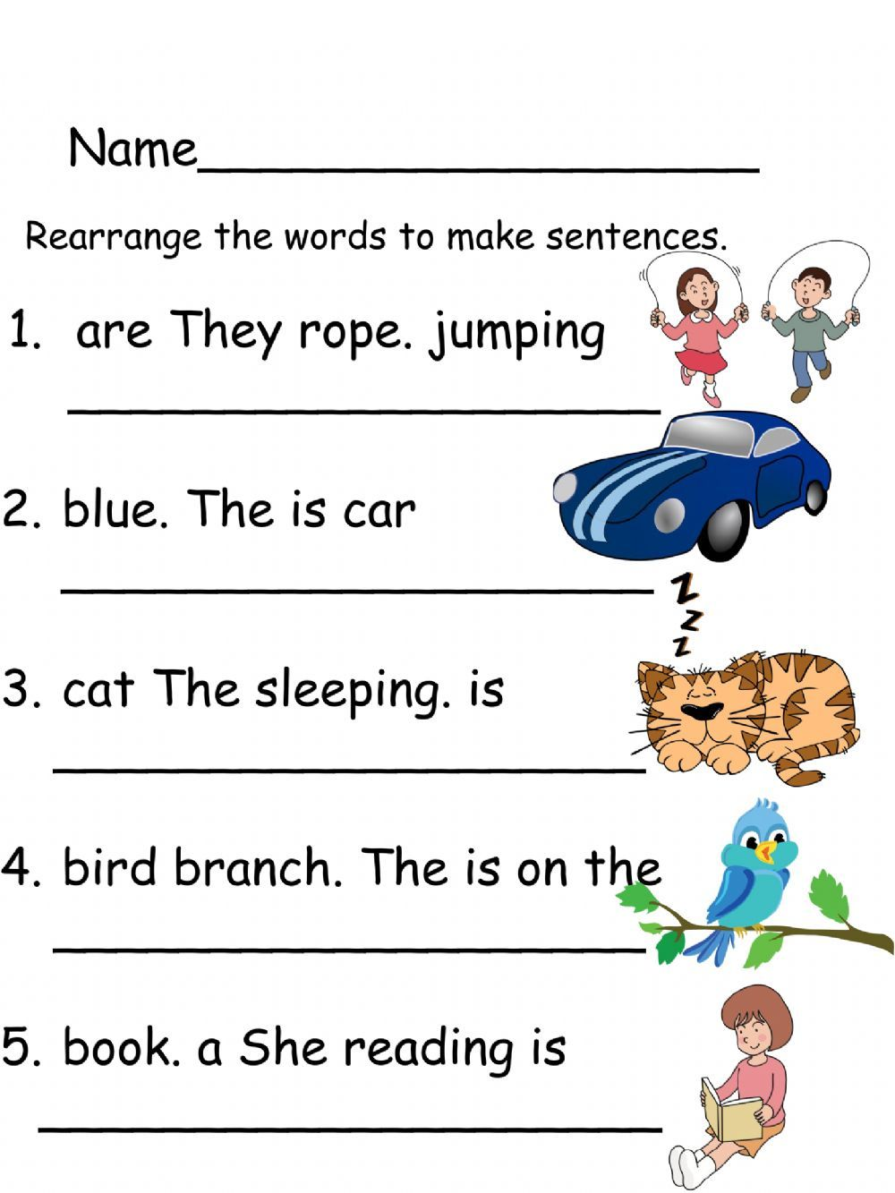
II. Rearrange the words to make sentences.
1 .this Friday / have we / a holiday
___________________________________________________
2. cooks / my mom/delicious food
____________________________________________________
3. welcomed /every guest / was
____________________________________________________
4. the thief / arrested / the policeman
____________________________________________________
5. bakes /a baker / brea
____________________________________________________

